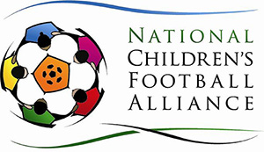
www.childrensfootballalliance.com & www.childrensfootballalliance.com/football-and-peace/
National Children’s Football Week
Press release
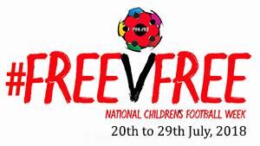
The National Children’s Football Alliance (NCFA) is delighted to announce the National Children’s Football Week 2018.
A chance for schools, clubs, organisations and families to celebrate football and ‘play’.
There are two themes to this year’s event, FREE v FREE a chance for children and their families to play for free. Any age, gender and ability.
We also celebrate the WW1 Christmas truces games as part of our Peace Field Project.
Just over a hundred years ago on Christmas eve 1914 the Allied troops played a game of football with German soldiers who only hours before had been slaughtering each other in the most brutal of wars. The power of football united enemies that day as they made new friends. This was the game that they had played as children in the fields and playgrounds. Jackets for goalposts and a ball.
Paul Cooper the NCFA’s Projects Director said; ‘Children play football for the human movement experience and the indescribable feeling that comes with it. National Children’s Football Week is a chance for all children and their families to have fun and ‘play’ football – its FREE. There are no hidden costs when families and friends pick up the ball and have a kick about. It is an opportunity for children to have their say and organise their own game.’
Raising awareness about the importance of family football for fun is the GOAL. Encouraging children and parents to take part and help organise games in any format or competition is a shared experience and if you are in a position to help facilitate a game of football in a park, a playground at a cub or even the garden, pick up a ball and Let Us Play.
We want to hear your story from the National Children’s Football Week.
For more information on the National Children’s Week and Peace Field Project please click on
www.childrensfootballalliance.com

